* **Fig0.alpha的凸起，alpha同步的同时，beta是去同步**

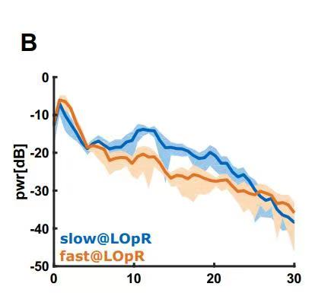

* **Fig1.黑白和彩色负荷总体趋势图**

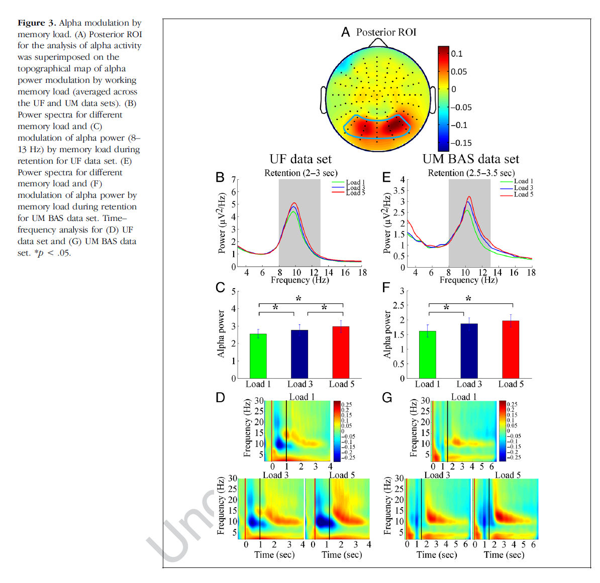

* **Fig.2 画黑白和彩色的不同**

Demonstrate important changes in the brain workload when moving from the first test to the second one. Changes concerning the θ wave are basically located at temporal (electrodes T3 and T6), parietal (P3 electrode) and occipital (electrodes O1 and O2) areas. For the αband, changes were mainly in brain regions: temporal (electrodes T3 and T6), central (electrodes C3, Cz and C4), parietal (electrodes P3, Pz and P4) and occipital (electrodes O1 and O2).

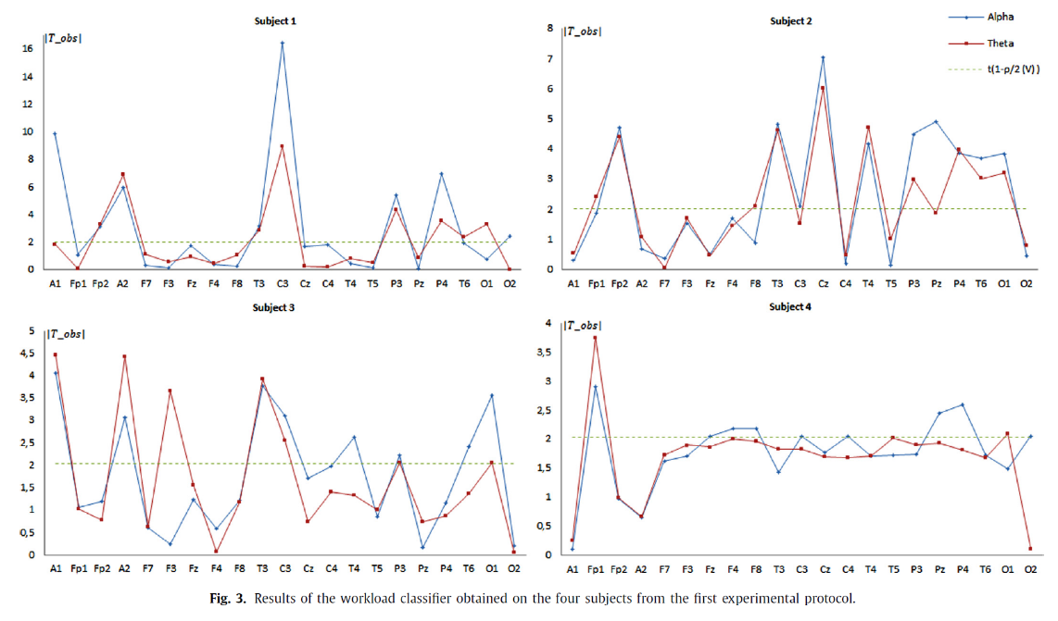

Curves in each plot correspond to the power spectra of each electrode used in this experimental protocol. Results show a significant decrease in powers when increasing the difficulty of the cognitive task.（electrodes: Oz, PO3,POz , O2,Iz, PO4,O1,Pz）



The reader can clearly note the decrease of the spectrum powers on all electrodes when moving from the cognitive task with low difficulty level to another with high difficulty level.



* **Fig3.高低认知水平脑拓扑图的比较，单个电极**





 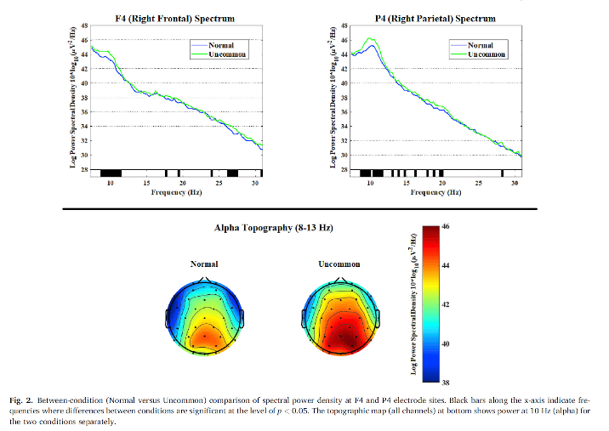

丑点的，Fig4，Fig5

* **Fig4 比较不同电极，高低math anxiety，画的latency图**

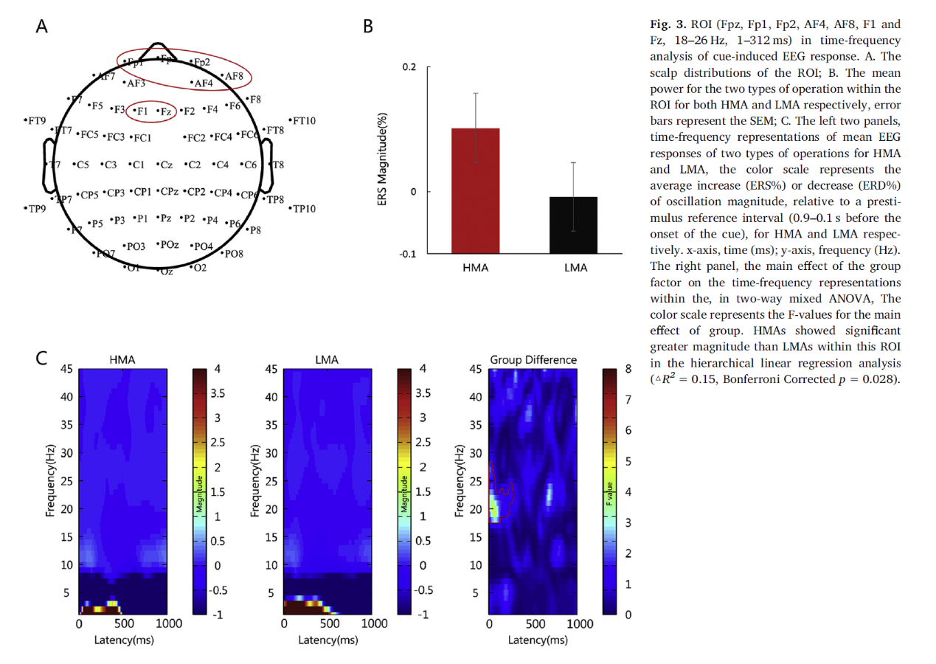

* **Fig.5 SVM分类**

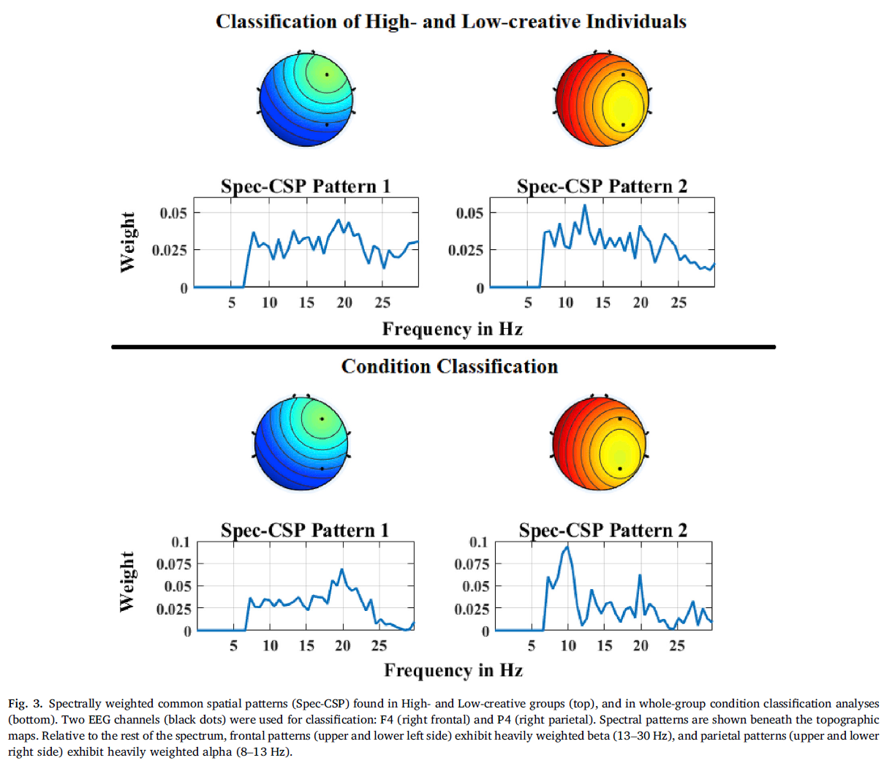

* **Fig.6 电极相关**







* **Fig.7 三种负荷状态，P300和theta、alpha**



* **Fig.7 Statistical Analyses用了Receiver Operating Characteristic (ROC) curve**



* **Fig.7 把每页ppt标个难度画一下？**

 Examples of reactivity of the thetaFz/alpha Pz ratio to continuous changes in task demands. Task setting: the subjects performed the single, dual, and multi conditions continuously, 7 min per condition, for a total time of 42 min. The value is averaged over 20 sec. The change between single compared to dual and multi was clear, but between dual and multi at the individual level varied somewhat more (clear in subjects 2 and 3, but not in 1). The fluctuating attention and/or effort of the subject may affect the ratio.

* **Fig.8 there exist specific neural patterns in high frequency bands for positive, neutral and negative emotions through time-frequency analysis.**

For positive emotion,it shows that energy of beta and gamma frequency bands increases whereas neutral and negative emotions have lower energy of beta and gamma frequency bands. While the neural patterns of neutral and negative emotions have similar patterns in beta and gamma bands, neutral emotions have higher energy of alpha oscillations. These findings provide fundamental evidences for understanding the mechanism of emotion processing in the brain.



* **Fig.8 混淆矩阵**



* **Fig.8 Gamma**

 

* **Fig.9 canonical correlation analysis (CCA)相关分析**



* **Fig.10 对比左右脑**

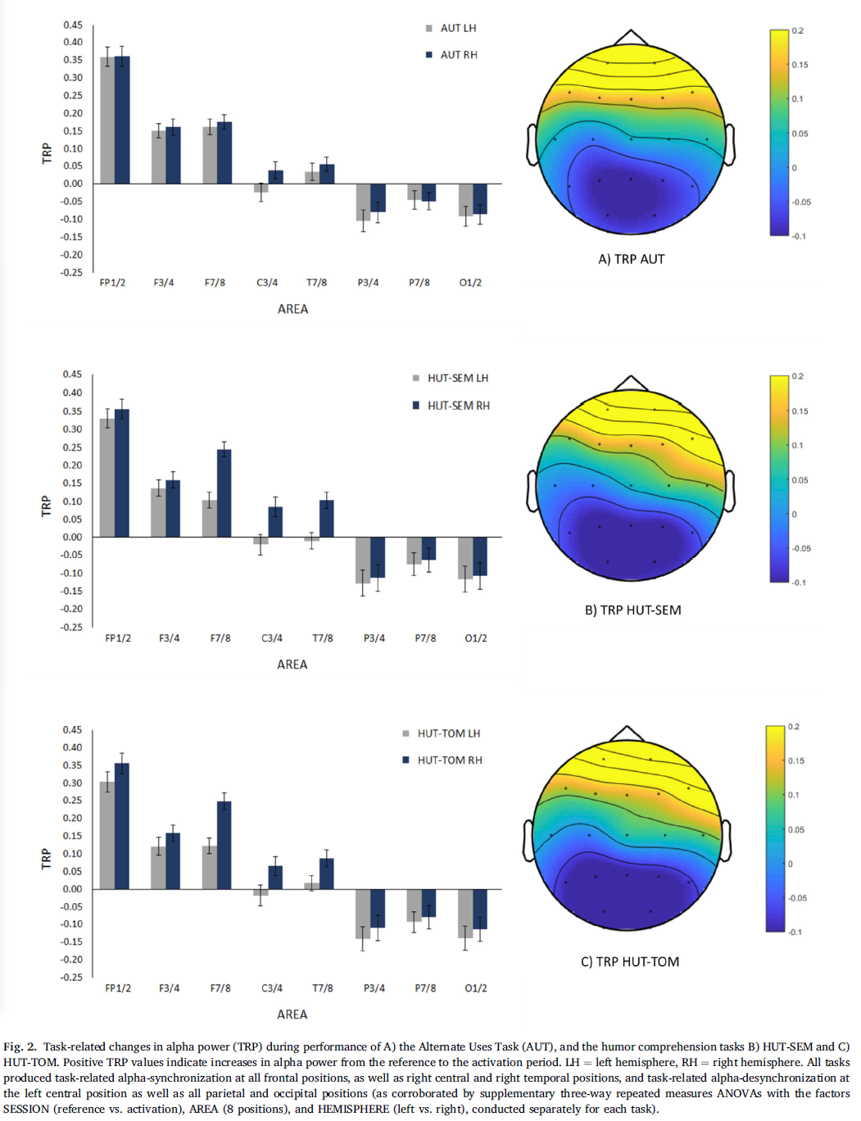

* **Fig.10 不同任务拓扑图差异**



* **Fig.11** Inter-trial coherence (ITC) allowed us to evaluate phase-locking of EEG signals to saccade and fixation onsets across EEG epochs. ITC was calculated as proposed by Delorme and Makeig（EEGLAB的工具箱，原文下载了Fig9. Delorme and Makeig）

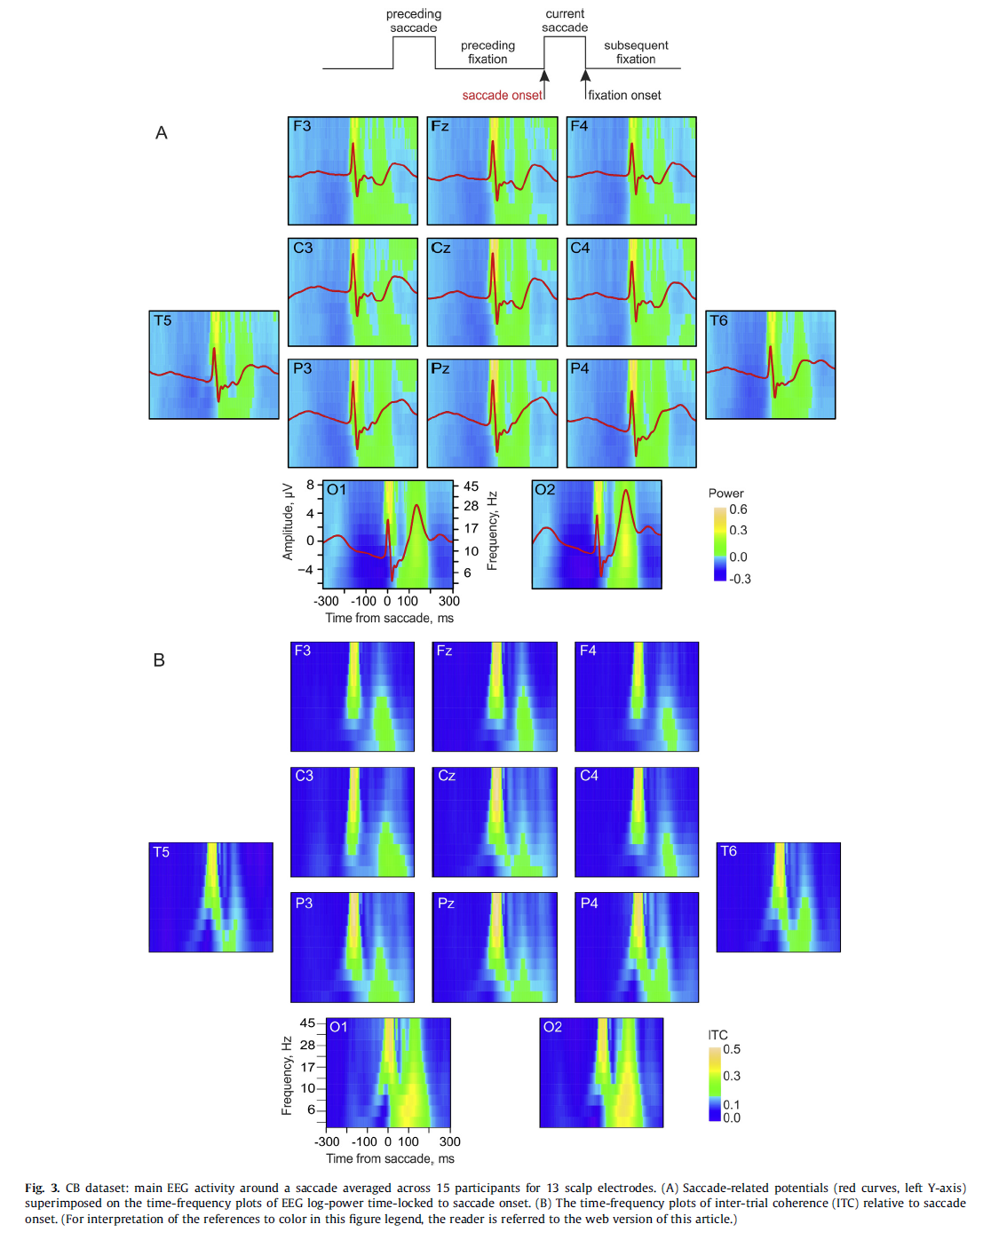

 

**这篇文章还有好些图**

* **Fig12. 主观认知负荷评测、考试得分和EEG**

